**Of RGSSA Flinders Ranges & Outback Tour October 28- Nov 3, 2025.**

**Tour Outline and Itinerary**

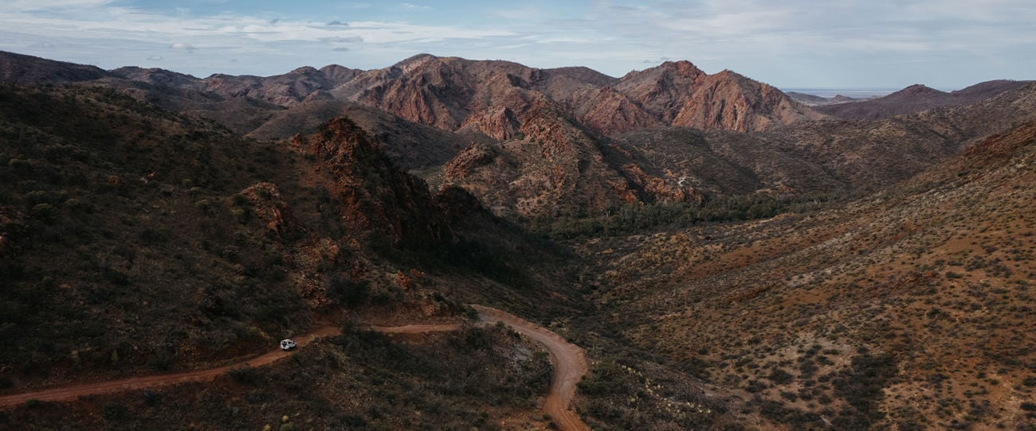

“The Flinders Ranges rival Uluru as Australia’s number one Outback tourist attraction. The Flinders are an entire mountain range containing towns, sheep stations, hundreds of kilometres of hiking trails, bountiful pockets of wildlife, caves with Aboriginal artwork, ruins of failed settlements, and mountains to climb and gorges to explore.”

Eric Hoffman, Sierra Guide to Adventuring in Australia 1990.

This is how noted US travel and nature writer, Eric Hoffman described the Flinders Ranges when I took him there in 1990. It certainly placed this quintessential landscape in our South Australian Outback right at the very pinnacle of recommended experiences. After some years since the RGSSA last ventured into this region, we are returning for a seven day trip by 4x4 coach for a limited number of participants to take in many of the highlights, old and new attractions with some behind the scenes insights.

**Day 1 – Adelaide to Rawnsley Park**

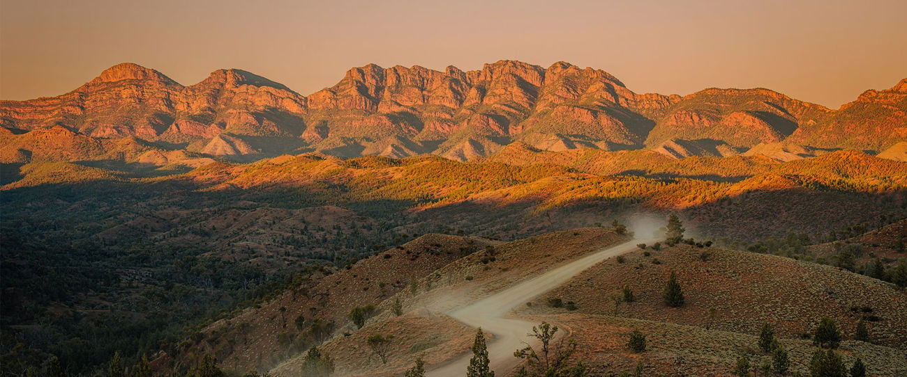Travel the back road through the Clare Valley, stopping along the way for lunch at the restored **Yanyarrie Hotel** in **Carriton** in the mid north. We finish at Wilpena Pound for an overnight stay at **Rawnsley Park Station**. Here Tony and Julie Smith have worked fastidiously as tourism pioneers, turning a sheep station into one of the premier tourist destinations in the central Flinders Ranges.

Dinner in the Woolshed Restaurant under the beetling silhouette of Rawnsley Bluff and a pre-dinner presentation of how Tony and Julie created this enterprise.

Lunch/Dinner

**Day 2 – Rawnsley Park – Leigh Creek**

Following breakfast, we make an early start travelling through the Flinders Ranges National Park to the historic mining town of **Blinman**. Robert Blinman, a local shepherd discovered copper ore in 1859. This led to a successful mining operation in the 1860s and much of the town’s history relates to this. We will undertake a morning tour of part of the restored mine followed by a light lunch at the **Blinman Hotel**.

After lunch we take a short drive to the nearby **Ediacara National Park** fossil reserve at Nilpena Station for a guided tour with the National Parks. This discovery of the world’s earliest life forms by Reg Sprigg in 1946, has now been recognised as a distinct geological period dating back to 635 million years.

Overnight accommodation and dinner **Leigh Creek Hotel**

Breakfast/Lunch/Dinner

**Day 3 – Leigh Creek – Arkaroola Wilderness Sanctuary**

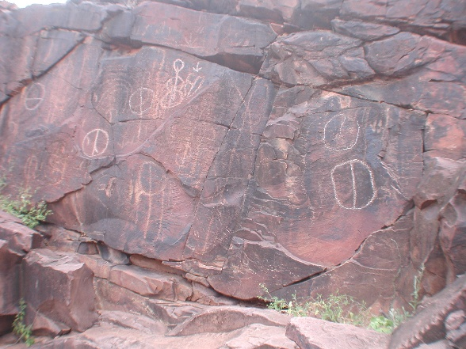

Another early start and we swing past the Copley Bakery for a dose of Quandong Pies and a visit to one of the best rock art sites in the Flinders Ranges at **Red Gorge**. Here our Adnyamathanha guide will meet us for the short journey to this amazing site with some of the best petroglyphs in the Flinders hammered into the rock thousands of years ago,

Following this we continue along the Balcanoona road towards Vulkathunha Gammon Ranges National Park with a light lunch at the **Iga Warta** community to hear some more of the local Adnyamathanha stories.

In the afternoon we arrive at **The Arkaroola Wilderness Sanctuary** for a two-night stay.

Arkaroola is the pinnacle of the north Flinders wilderness and amongst the most rugged of the range landscapes. Home to the Akurra, creation serpent of the Adnyamathanha it was the site of intensive uranium prospecting in one of the most mineral rich geological provinces in Australia. The nearby Yudnamutana copper mine flourished in the 1860s and Douglas Mawson discovered uranium nearby. Geologist Reg Sprigg was so taken by this landscape that he purchased the 610 square kilometres pastoral lease. He and his family fought an ongoing battle to preserve the area from future mining and in 2011 the state government enacted special purpose legislation to prohibiting mining and exploration in the area. Today Doug Sprigg carries on the family tradition managing this amazing sanctuary providing a range of tourism experiences, including his famous night sky observatory. Doug will share his personal story during our stay.

Dinner and Observatory Star Gazing

**Day 4 – Arkaroola Wilderness Sanctuary**

Today the morning is taken up with the famous **Ridge Top tour** an experience bar none in the Flinders Ranges as you follow the stupendous ridge top mining exploration track to observe at first hand this classic scenery from the back of open four-wheel drives. Even if you have done it before it is something that will remain a highlight of any Flinders experience.

Afternoon to chill out in the Arkaroola surroundings and take in the museum displays or just relax until sunset drinks and dinner.

Breakfast/Lunch /Dinner and Observatory Star Gazing

**Day 5 – Arkaroola to Marree**

Today after breakfast we do an early departure and follow the 4x4 track to the old **Bolla Bollana** smelter and waterhole, home of the Akurra. We continue on the back tracks through Illinawartina Pound to **Mt Serle** were nearby Ram Paddock Gate (Minerawuta) provided one of the refuges for the Adnyamathanha during the turbulent settlement period. From here we return to the Outback Highway visiting the **Ochre Cliffs** at **Lyndhurst** and stopping at **Farina** on our way to **Marree**. Farina was the original railhead for the great northern railway and the name reflected the hope of it becoming a major wheat growing district. This never eventuated as the rail pushed on to Marree to become the focus for the northern railway. Farina today has been lovingly restored by volunteer labour and is one of the outback’s classic ghost towns with a thriving bakery/café in the tourist season.

Breakfast/Packed Lunch/Overnight and Dinner Marree Hotel

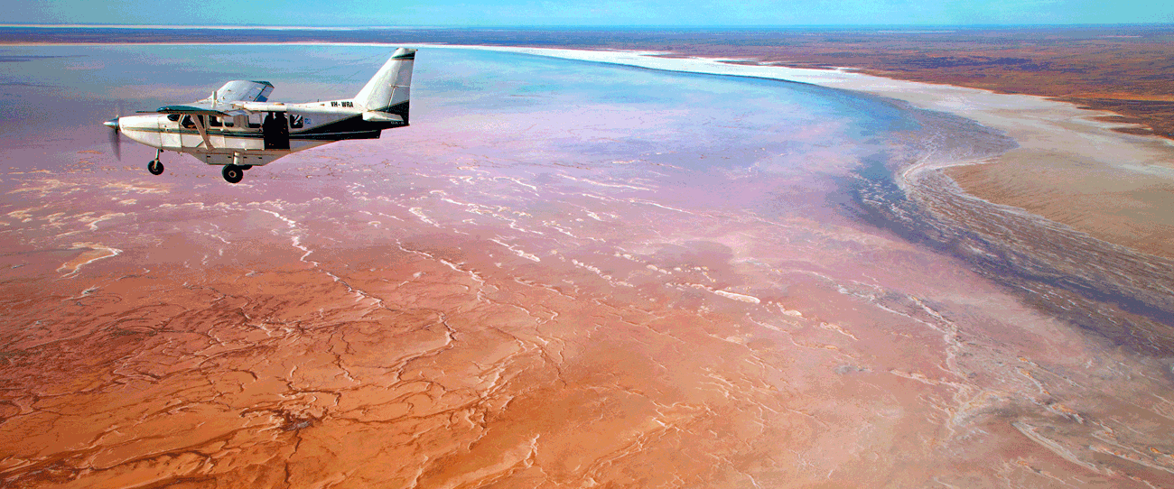**Day 6 – Marree to Roxby Downs**

Marree is the starting point of two of the Outback’s most iconic tracks, the **Birdsville and Oodnadatta Track**s. It is also the gateway to Kati Thanda Lake Eyre, Australia’s lowest point 15 metres below sea level. It is the drainage point for the desert rivers terminating in Kati Thanda and the heart of the Lake Eyre Basin, one of the world’s largest unregulated desert river drainage systems. With record rains, flows in the main tributaries, the Cooper and Georgina/Diamantina rivers are flowing and a mega fill of Lake Eyre, similar to 1974 is predicted. There will be **opportunity to do an early morning charter flight at own expense** to see this once in a lifetime phenomenon.

After breakfast and scenic flights at own expense we will meet with local Arabana elder Reg Dodd, the ‘Lake Eyre Man’. Reg will take us on a morning tour to **Lake Eyre South** and explain the many aspects along the way of mound springs, Finnis Springs Mission, ancient seabeds and petrified forests.

We then follow the Borefield Road to **Roxby Downs,** site of one of the largest Uranium/Copper Mines in the world by BHP Billiton at Olympic Dam.

Breakfast/Packed Lunch/Dinner/Overnight Roxby Downs Motel

**Day 7 Roxby Downs - Adelaide**

After breakfast we do a short run to nearby **Andamooka** one of Australia’s earliest and once remotest Opal mining centres with a rich history and colourful characters. Some of the locals will show us around the town and diggings and we will learn at firsthand about the crazy times in the 60s when this was the real wild frontier of Outback South Australia.

We continue our journey back south past the Woomera Rocket Range for a late lunch at the **Arid Lands Botanic Garden** in Port Augusta. From here it is all downhill to arrive back in Adelaide at the bus depot around 1900.

Breakfast/Lunch own volition.

Tour Inclusions

* Travel in Kanga luxury 4x4 purpose-built coach.
* Most meals unless otherwise designated.
* Accommodation, entry fees, attractions (excluding scenic flight).
* Expert guiding and commentary.
* Meet the locals for extra inputs.
* Limited numbers
* **Cost $ 2760 Twin Share Single Supplement $300 No-members $2860**
* **Deposit $ 500 by Friday 16 May – Balance Friday September 26**

