RGSSA Postgraduate Symposium

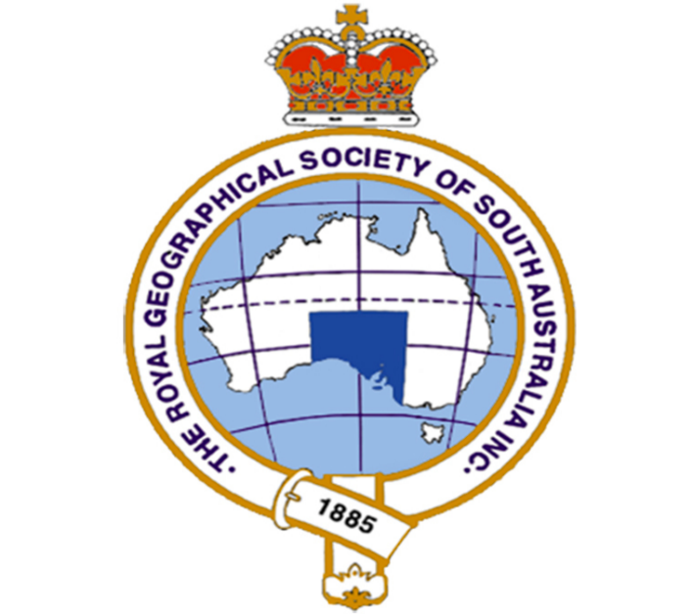

Friday October 24th 2025

Bradley Forum, Level 5, Hawke Building,
City West Campus, University of South Australia

Programme

0900 – 0930 Coffee and tea available

0930 Welcome from Prof. Iain Hay, Director RGSSA/Flinders University

0940 Introduction to the Symposium from Prof. Guy M Robinson, Vice-President RGSSA/University of Adelaide

0950 The audience introduces itself …. Say ‘hi’ to participants and the audience

1000 – 1120 Socio-economic development in the Global South (Chair Prof Guy Robinson)

Munkhzul Chimid-Ochir | Flinders | Initial findings: The paradox of high human development with persistently high poverty and inequality in Mongolia
Agung Yoga Asmoro | Flinders | “Spectators”’ in their own economy: The insider–outsider paradox in Indonesian tourism villages
Zhongqi Feng | Adelaide | Stakeholders’ perspectives on the role of returnee entrepreneurs in rural revitalization in a Chinese Township
Pragya Timsina | Adelaide | Contested agricultures: Power dynamics, resilience and missed opportunities among smallholder rice farmers in Assam

1120 – 1130 Coffee break

1130 – 1215 Prof. Timothy Cavagnaro (Pro Vice-Chancellor (Research Training and
Capabilities) and Dean of Graduate Research, Flinders University
‘The role of Artificial Intelligence in HDR research’

1215 – 1315 Climate change in Bangladesh and Indonesia (Chair: Professor Delene Weber, UniSA)

Md Torikul Islam | Adelaide | Fragmented promises, uneven outcomes: Institutional effectiveness in agriculture under climate stress
Raisa Savitri Ramadhani | Adelaide | The dual nexus: Industry as victim and driver. The need for climate adaptation in industrial estate development in Indonesia
Snigdha Roy | Adelaide | Climate adaptation in agriculture: Gender perspectives

1315 – 1400 Lunch

1400 – 1540 Research focusing on issues in South Australia/Victoria (Chair: Prof. Iain Hay)

Obed Twumasi Ankrah | UniSA | Harnessing water sensitive urban design (WSUD) for climate change resilience: Analysis of planning policies and practices in Greater Adelaide
Virginie Ducruc | Adelaide | Structuration in practice: Household dynamics and sustainable food choices in South Australia
Jared Leo | Adelaide | Breaking the energy loop: Design, behaviour and governance in Adelaide’s purpose-built student accommodation
Antoinette M Hennessy | Adelaide | Participation and consent : A reflection on applying collaborative research and co-design principles
Glenda Roberts | Massey Uni, NZ | Should trees be considered more important than roads? An exploration of the impacts of development on Nature, First Nations people and Country
Rebecca Hicks (UniSA) ‘Exploring spiritual relationships to Country/place in South Australian education’ will be unable to present because of a family bereavement. Her Abstract is included in the ‘Abstracts’ document.
1540 - 1615 Prof. Delene Weber (UniSA) ‘Overcoming problems along the PhD journey’

1615 – 1735 Development Studies (Chair: Prof. Udoy Saikia, Flinders U)

Vito C. Hernandez | Flinders | Early human dispersals and occupations of Pleistocene Southeast Asia: a micro-geoarchaeological approach
U-Tong Evelyn Tan | Adelaide | Exploring preschool educators' perspectives and approaches to environmental education for young children in Singapore
Christopher Hogan | Flinders | Investigating wellbeing and development outcomes of Ni-Vanuatu labour migration through the Pacific Australia Labour Mobility Scheme
Pavithra Darshani Wickramage | Flinders | Married women’s autonomy and its impact on reproductive health: Regional differences in Sri Lanka

1735 Wrap-up and Discussion

Catering will be provided by Sit Lo: quality South-East Asian inspired Vietnamese food, and The Ivy Café: a wide selection of teas, herbal infusions, renowned for the special house-blend.

++++

The Society’s Purpose is to:
- Advance public awareness of, and interest in, Geography and related disciplines, including environmental issues.
- Encourage research and scholarship in Geography.
- Recognise and reward achievements in Geography.
- Commemorate past achievements of significance to Geography.
Membership of the Society is by subscription and is open to anyone. While the Society takes a special interest in the geography of South Australia and its immediate region, it also extends to the global scale. https://rgssa.org.au/the-society/membership

This is achieved through:
- A program of public lectures, exhibitions and field activities.
- Publishing geographical material, including fully refereed research papers and items of popular and topical interest.
- Encouraging interest in all aspects of environmental, economic and social geography.
- Maintaining an extensive library and historical collections.
- Providing grants for research and awards to geography students and outstanding geographers.
- Conserving and managing collections and monuments relating to the geographical heritage of South Australia and other parts of Australia.

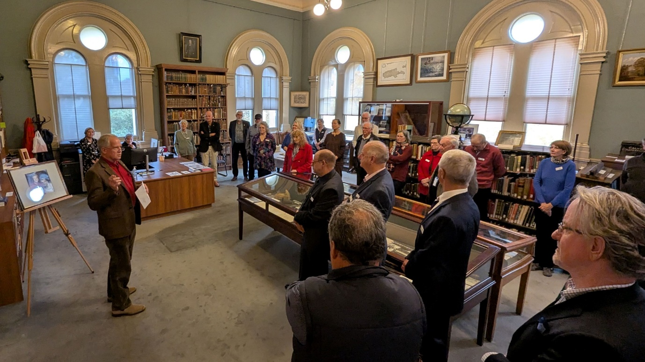
Official opening of the Society’s refurbished Library earlier this year.

